

**ANL 252 Python For Data Analytics**

**End-of-Course Assignment**

**July 2021 Presentation**

**Done by:**

**Ong Guo Lun (M1072994)**

**The Script**

"""

Created on Sat Sep 11 12:36:23 2021

@author: alanonggl

"""

#Importing all the libraries required for questions 1 & 2

import numpy as np

import pandas as pd

import sqlite3

from sklearn import linear_model

from collections import defaultdict

#Display the "ship.csv" and indicating the missing values as NaN

print("___________________1a(i)___________________________")

ship = pd.read_csv('ship.csv', na_values='.')

print(ship)

#Renaming the requested variable names of the ship dataset

print("___________________1a(ii)___________________________")

ship = ship.rename(columns={"T": "types", "A": "c_years", "P": "o_periods", "MS": "s_months", "Y": "incidents"})

print(ship)

#Creating a new object "shipgroup" to keep the resulting table in 1a(iii)

print("___________________1a(iii)___________________________")

shipgroup = ship.groupby(['types', 'o_periods'])[['s_months', 'incidents']].mean().round()

print(shipgroup)

#Replacing missing values in "ship.csv" for "s_month" & "incidents"

#Using the respective means of other ships' data that have the sames "o_periods" & "types"

print("___________________1a(iv)___________________________")

ship['s_months'] = ship['s_months'].fillna(ship.groupby(['types', 'o_periods'])['s_months'].transform('mean').round())

ship['incidents'] = ship['s_months'].fillna(ship.groupby(['types', 'o_periods'])['incidents'].transform('mean').round())

print(ship)

#Saving the variable from "incidents" to a DataFrame called "y"

print("______________________1a(v)________________________")

y = pd.DataFrame(ship['incidents'])

print(y)

#Converting to categorical variables for "types", "c_years" & "o_periods"

print("______________________1b(i)________________________")

ship = ship.astype({"types": 'category', "c_years": 'category', "o_periods": 'category'})

print(ship)

#Converting the categorical variables to dummy variables

#Keeping the result in DataFrame named "x"

print("_____________________1b(ii)________________________")

x = pd.get_dummies(ship, columns=['types', 'c_years', 'o_periods'])

print(x)

#Scaling down the wide range of values

#Log-transforming the dataframe "x"

#Naming the transformed variable "log_s_months"

#Attaching to the dataframe "x" & "ship"

print("_____________________1b(iii)_________________________")

ship['log_s_months'] = np.log(ship['s_months'])

print(ship)

x['log_s_months'] = np.log(x['s_months'])

print(x)

#1c

#Using the current dataset from "ship.csv", there will not be enough data.

#Not having enough data, the training set will not get recognised enough and become a successful set.

#Similarly, the testing set is unable to check properly as the dataset is not enough.

#Another test instead can be the "k-overlay cross-approval".

#Saving the dataframe "ship" to a new csv "ship_prepared.csv"

#Creating a database "ship.db"

#Exporting the dataframe to "ship.db" as tables

print("________________________1d______________________")

ship.to_csv('ship_prepared.csv')

conn = sqlite3.connect('ship.db')

ship.to_sql('ship_table', conn, if_exists='replace', index=False)

conn.commit()

conn = sqlite3.connect('ship.db')

c = conn.cursor()

c.execute('''

SELECT

* from ship_table

''')

shipdb_df = pd.DataFrame(c.fetchall())

print (shipdb_df)

#2a

#The corresponding scikit-learn mobile will be the “sklearn_model”

#The parameters are “max_iter: int, default=100” which determine the highest number of iterations for this regression to meet, “alphafloat, default = 0.0001” which is to stop overfitting and making regularization stronger via multiplying the constant and “fit_intercept: bool, default=True” which is to count this regression’s intercept and the default is set to not true, the count will not include the intercept. (scikit-learn developers, 2007 - 2020)

#The Attributes are “intercept_:float or array of shape (n_targets,)” which will produce the β0’s intercept and “coef_: array of shape (n_features, ) or (n_targets, n_features)” which produces the coefficients’ arrangement.

#The methods are “score(X, y[,sample_weight]) which calculate the deviance’s percentage, “get_params([deep]) which produces the parameters of the coefficients, “predict(X) which will anticipate via using this given model and “fit(X,y[,sampe_weight]) to fit into this regression.

#Fit the suggested Poisson regression with dataframes "x" & "y"

#Producing a dataframe to show the coefficients towards the corresponding labels

print("________________________2b______________________")

arr_x=x.to_numpy()

arr_y=y.to_numpy()

model = linear_model.PoissonRegressor()

model.fit(x, y)

df_xy=defaultdict(float)

df_xy['β0']=model.intercept_

i=1

for val in model.coef_:

df_xy['β'+str(i)]=val

i=i+1

print(df_xy)

#Calculating devariance with using the score() function

print("________________________2c______________________")

model_y=model.predict(arr_x)

D = []

#j is used instead to represent Y in the equation D in this question

#This is needed as we already use y for question 1 and not to confuse the script

for j in arr_y:

D.append(np.sign(j-np.mean(model_y)*(2*y*np.log(j/np.mean(model_y))-(j-np.mean(model_y)))))

print("The resulting deviance will be ",np.mean(D))

**The Output**

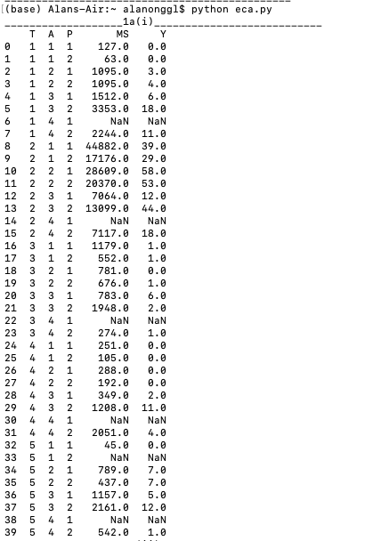

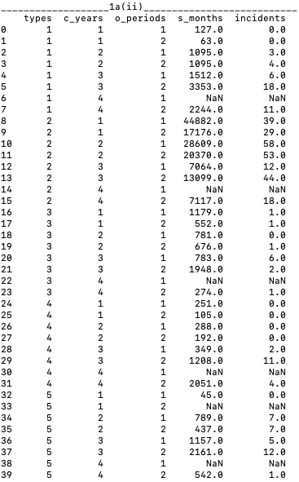

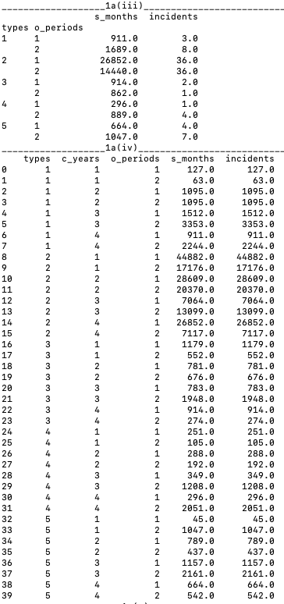

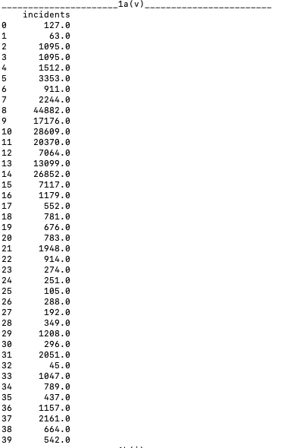

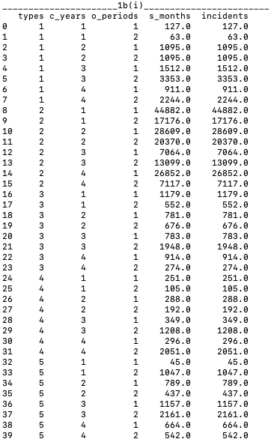

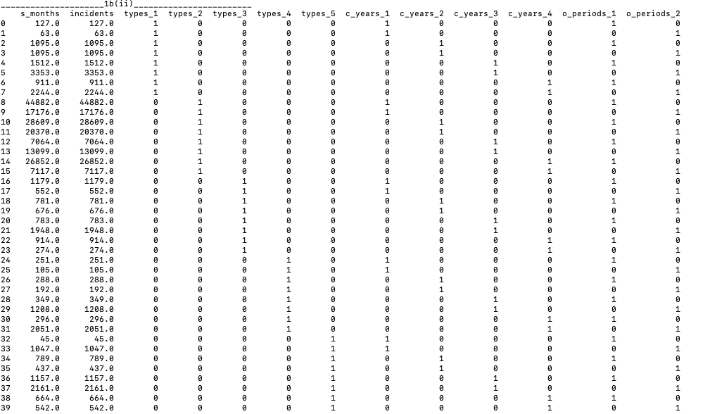

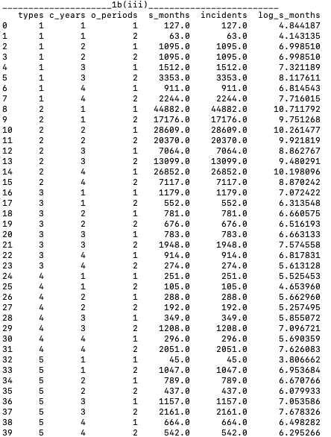

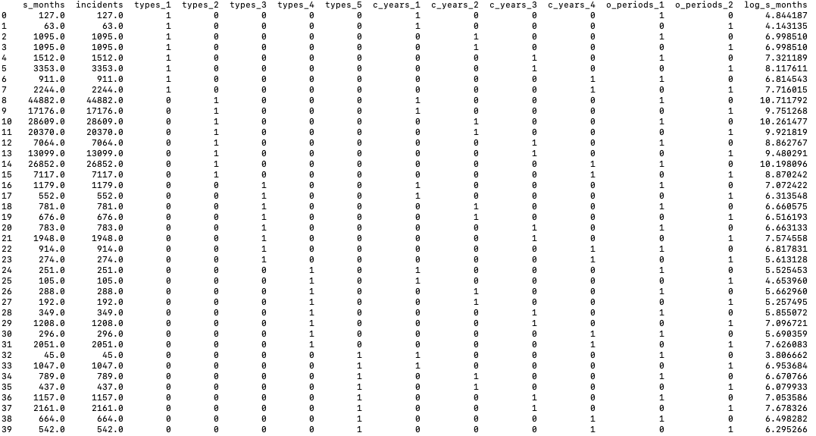

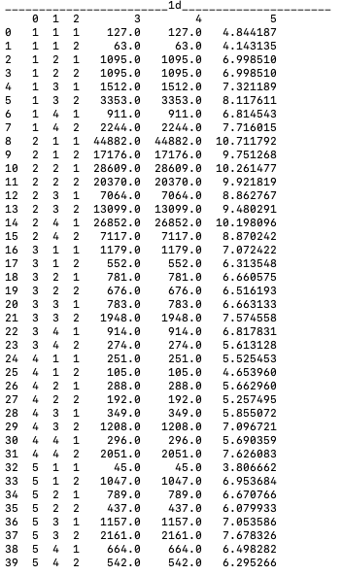

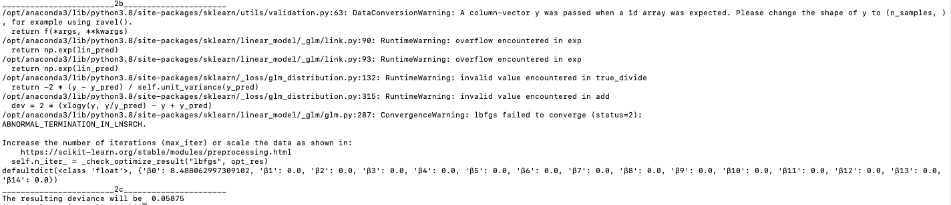

**Reference**

sklearn.linear_model.LinearRegression (2007 - 2020). Retrieved from <https://scikit-learn.org/stable/modules/generated/sklearn.linear_model.LinearRegression.html>

sklearn.linear_model.LogisticRegression (2007 - 2020). Retrieved from <https://scikit-learn.org/stable/modules/generated/sklearn.linear_model.LogisticRegression.html>

sklearn.linear_model.Perceptron (2007 - 2020). Retrieved from <https://scikit-learn.org/stable/modules/generated/sklearn.linear_model.Perceptron.html>